where 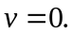
Papers written by Australian Maths Software

SEMESTER ONE

REVISION 2

MATHEMATICS METHODS
UNIT 3

2016

SOLUTIONS

SECTION ONE
1. (8 marks)
(a) 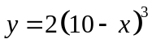 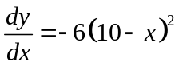 ✓✓ -1/error (2)

(b) 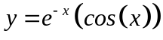
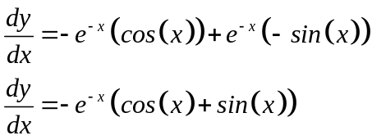
✓ ✓

✓

(3)

(c) 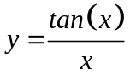 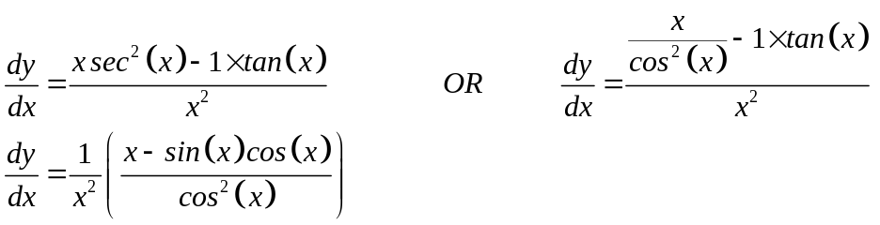 (2)
✓ ✓

2. (6 marks)

(a) (i) 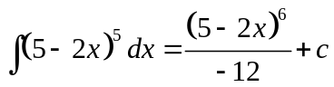 ✓ ✓ (2)

(ii) 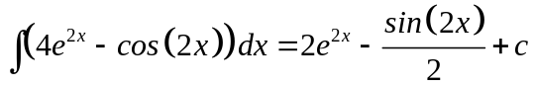 ✓ ✓ (2)
(b) 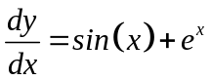
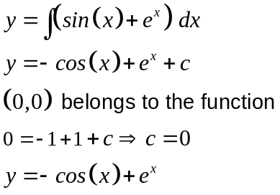
✓
✓
(2)

3. (7 marks)
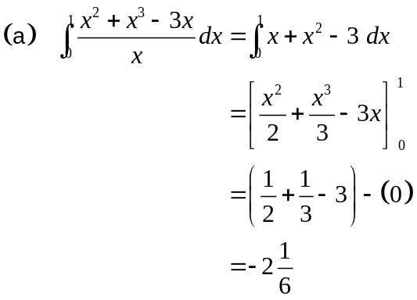
✓
✓
✓
(3)
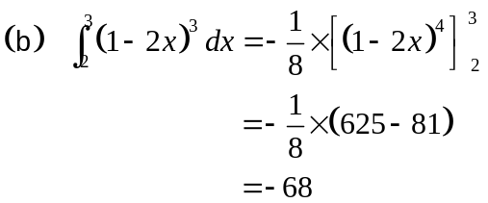
✓
✓
(2)

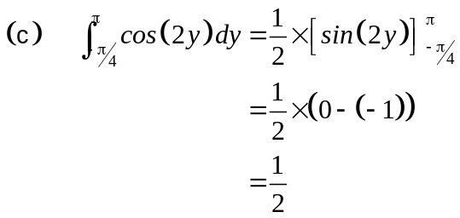 (2)
✓
✓
4. (9 marks)
(a)
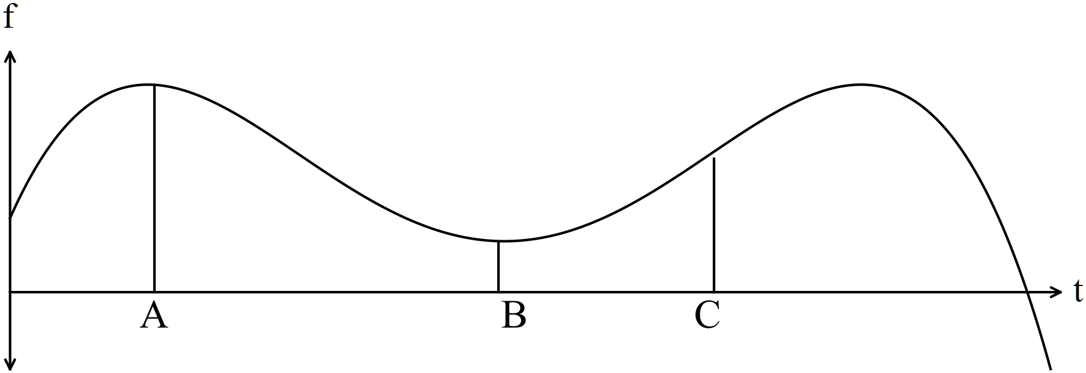
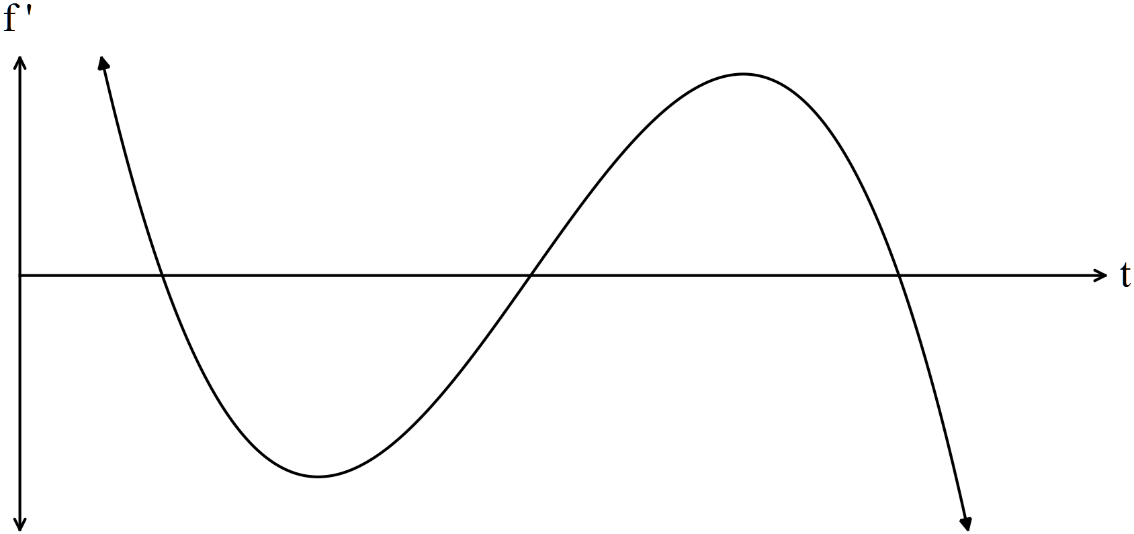
✓✓

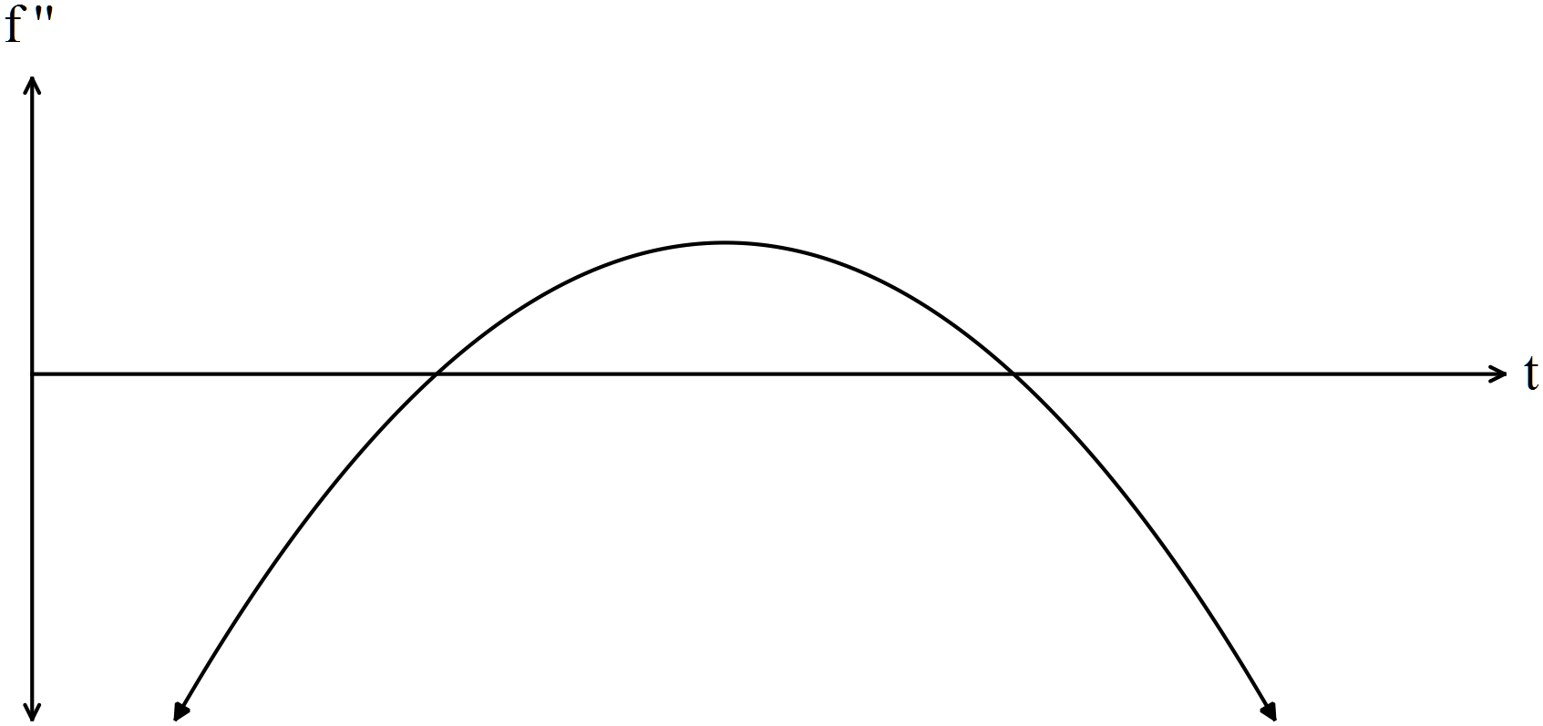
✓✓

(4)

(b) (i) At t = A, there is a maximum turning point where the gradient is zero and the
second derivative is negative.
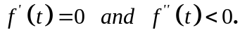 ✓✓ (2)
The particle changes direction so velocity changes from positive to negative.
As the velocity is decreasing, there is negative acceleration that can be seen
in f”.
(ii) At t = B, there is a minimum turning point where the gradient is zero and the
second derivative is positive.
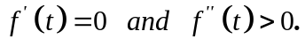 ✓✓ (2)
The particle changes direction so velocity changes from negative to positive.
As the velocity is increasing, there is positive acceleration that can be seen
in f”.

(iii) At t = C, there is a point of inflection where the second derivative is zero.
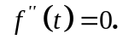 ✓ (1)
There is also a turning point on the 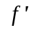 graph. On the f graph it can be seen that
while the particle still has a positive gradient; before the point of inflection the
gradient was increasing but decreasing after the point of inflection.
Hence the turning point on the graph.
As 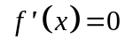 it follows that 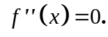 .

5. (5 marks)
Given 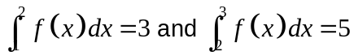
(a) 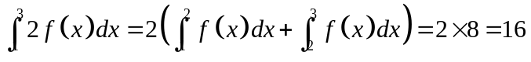 ✓ (1)
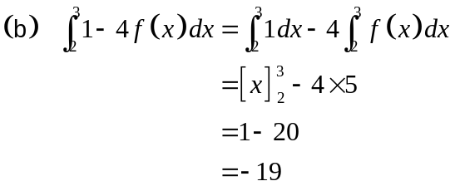
✓
✓
(2)
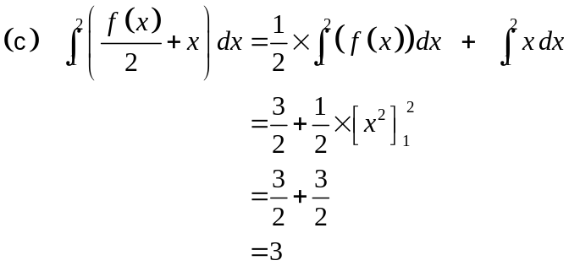
✓
✓
(2)
6. (8 marks)
(a) (i) 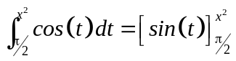
✓
✓
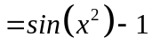 (2)

(ii) 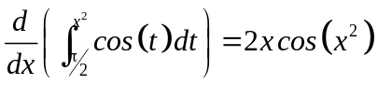 (2)
✓ ✓

(b) (i) 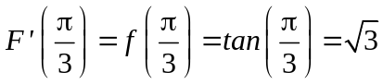 (2)
✓ ✓
(ii) 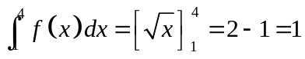 (2)
✓ ✓
7. (7 marks)
(a) Given 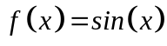 and 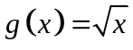
(i) 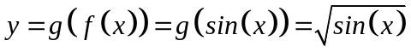. ✓ ✓ (2)
(ii) 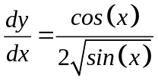 ✓
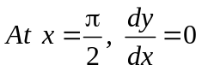 ✓ (2)
(b) 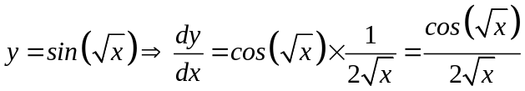 (2)
✓ ✓

END OF SECTION ONE
SECTION TWO
8. (8 marks)

(a)
Price per entry | Number of people attending | Revenue
$26 | 97 | $2 522
$25 | 100 | $2 500
$24 | 103 | $2 472

✓

✓

(2)
(b)
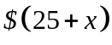 | 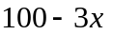 | 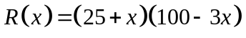
✓

(1)
(c) Maximum area occurs when 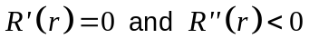
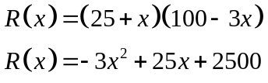
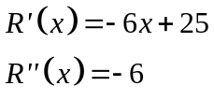
✓
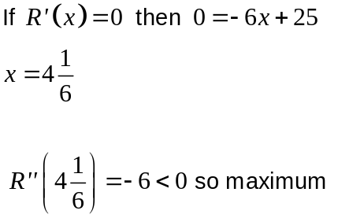
✓
✓
At 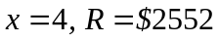
✓
At 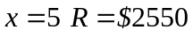

For maximum revenue, the committee should charge $29 (= 25+4). (5)

9. (10 marks)
(a) (i) 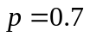
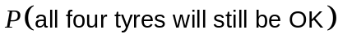
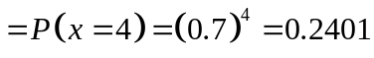 ✓✓ (2)
(ii) 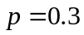
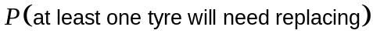
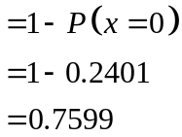 (2)
✓
✓

(iii)
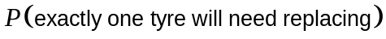
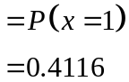 (2)
✓
✓

(b) (i) 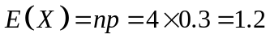 (2)
✓ ✓
(ii) 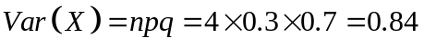 (2)
✓ ✓

10. (4 marks)
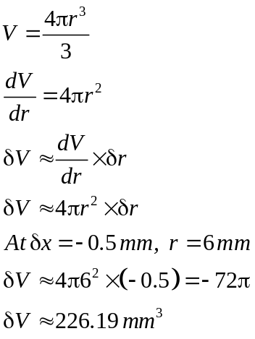
✓
✓
✓
✓
The decrease in volume when the diameter is 11 mm rather than 12 mm is
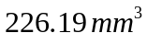.
(4)

11. (6 marks)
(a) 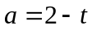
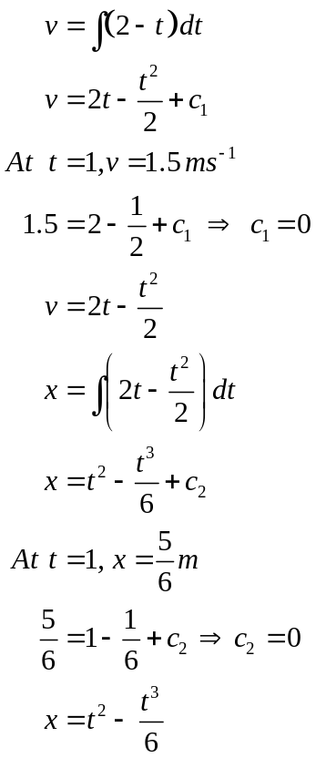 (3)
✓
✓
✓

✓
(b) Changes direction at 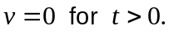
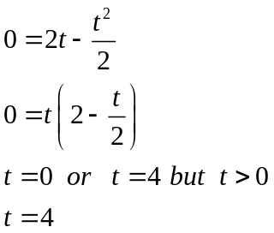
✓
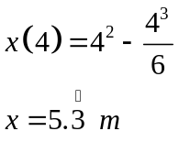
✓
(3)
12. (7 marks)
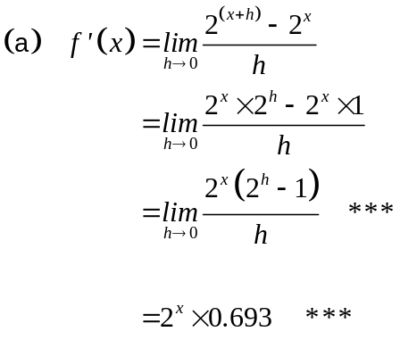
✓✓
✓✓
(2)
(2)
Therefore if 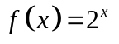
then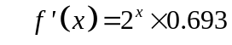 *** (1)
✓

(b) (2)

13. (11 marks)
(a) (i) 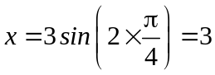 ✓ (1)
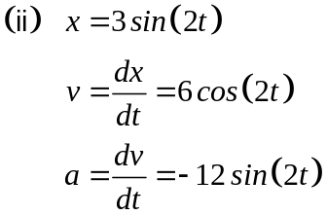
✓
✓
(2)
(iii) 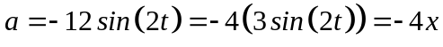 where 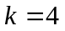 ✓ (1)
✓
(b) 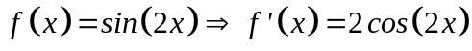
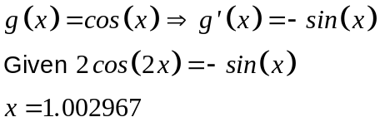
✓
✓
(3)

(c) (i) and (vi) have the same derivative because 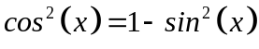 ✓✓
(ii) and (v) have the same derivative as they differ only by a constant. ✓✓
(iii) and (iv) do NOT have the same derivative. They are horizontal translations
of each other. ✓✓ (4)
14. (5 marks)

(a) 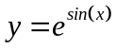
(i) 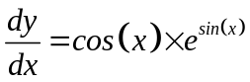 ✓ (1)
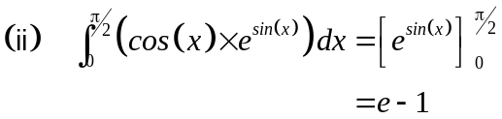
✓
✓
(2)
(b) 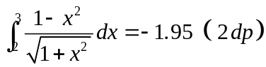 ✓ ✓ (2)

15. (8 marks)

(a)
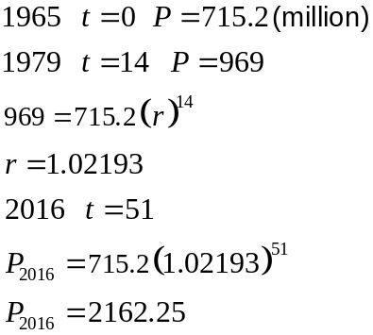
✓
✓
✓

The expected population in 2016 was 2162.25 million people. (3)

(b)
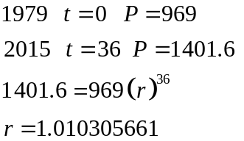
✓
✓
The annual rate of growth from 1979 was 1.03% (rather than 2.193%). (3)
✓

(c) From 1979,
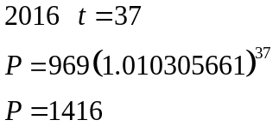
✓
✓
The difference in population is 746.2 million people. (2)

16. (11 marks)
(a) (i) (2)
✓ ✓
(ii) 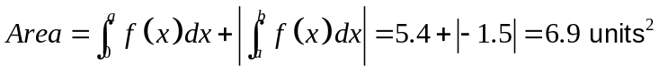 (2)
✓ ✓

(b) (i) From below
✓✓
From above
✓✓
The average of the two estimates is 4.64 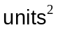 ✓ (5)

(ii) 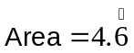 ✓✓ (2)

17. (5 marks)
(a)
 | 1 | 2 | 3 | 4 | 5
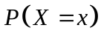 | 0.1 | 0.3 | 0.3 | 0.2 | 0.1

✓✓

(2)
(b) 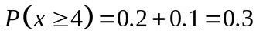 (1)

(c) 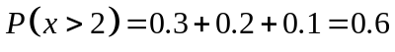 (2)

18. (8 marks)
(a)
x | 2 | 3 | 4 | 5 | 6 | 7 | 8 | 9 | 10
P(X = x) | 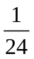 | 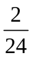 | 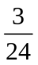 | 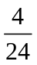

✓✓✓
(3)

(b) 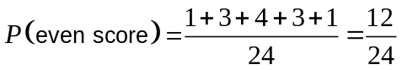 (2)
✓ ✓
(c) 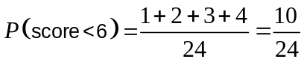 (2)
✓ ✓
(d) 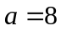 ✓ (1)

19. (12 marks)

(a) The data does represent a discrete random variable as the probabilities
add up to 1. ✓✓ (2)

(b) (i)
 | 1 | 2 | 3 | 4
 | 0.5 | 0.25 | 0.125 | 0.125

✓✓

(2)
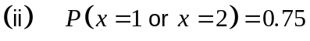 ✓ (1)

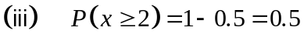 ✓ (1)

(iv) ✓ 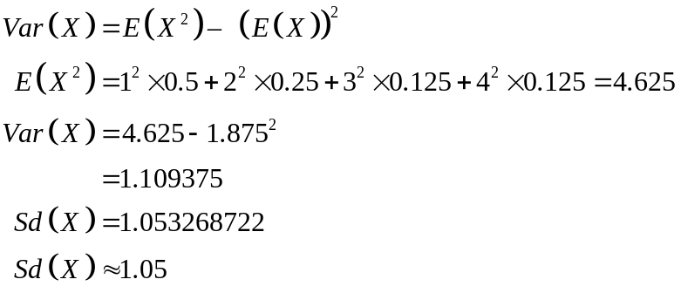
✓

✓

✓

(4)
(c)
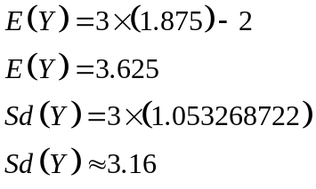
✓

✓

(2)
20. (5 marks)
✓
✓
✓✓
✓
(5)

END OF SECTION TWO

